**Software Requirements**

**Specification**

**For**

**HOPE - University Blood Donation Application**

Prepared by :

| **Specialization** | **SAP ID** | **Name** |
| --- | --- | --- |
| DevOps | 500069044 | Ankur Sehrawat |
| DevOps | 500069112 | Anubhav Deshwal |
| DevOps | 500069625 | Deepen Lakra |
| DevOps | 500067066 | Akshat kaushik |



Department of Informatics

School Of Computer Science

UNIVERSITY OF PETROLEUM & ENERGY STUDIES,

DEHRADUN- 248007. Uttarakhand

**TABLE OF CONTENTS**

|  | | **Topic** | | | **Page No** | |
| --- | --- | --- | --- | --- | --- | --- |
|  | | Table of Content | | | - | |
|  | | 1 | Introduction | | 1-2 | |
|  | |  | 1.1 Purpose of the Project | | 1 | |
|  | |  | 1.2 Target Beneficiary | | 1 | |
|  | |  | 1.3 Project Scope | | 1 | |
|  | |  | 1.4 References | | 2-3 | |
|  | | 2 | Project Description | | 4-11 | |
|  | |  | 2.1 User Classes and Characteristics | | 4-5 | |
|  | |  | 2.2 Project Features | | 5 | |
|  | |  | 2.3 User Classes and Characteristics | | 6 | |
|  | | 3 | System Requirements | | 9 | |
|  | |  | 3.1 User Interface | | 9 | |
|  | |  | 3.2 Software Interface | | 9 | |
|  | |  | 3.3 Database Interface | | 9 | |
|  | |  | 3.4 Protocols | | 9 | |
|  | | 4 | Software Quality Attributes | | 10 | |
|  | | 5 | Other Requirements | | 11 | |
|  |  | | |  | |

**PURPOSE OF THE PROJECT**

There is an expectation that the blood will always be there when it is really needed. Blood donor volunteers constitute the main supply source in an effective blood supply chain management. They feed blood stocks through their donation. In an emergency situation, if the stocks are insufficient, the only source of blood supply will be the people who come to the health center and donate the blood on a voluntary basis. A smart phone application is developed to facilitate the identification of the nearest available blood donor volunteer and the communication with him/her in the emergency situations where the blood can’t be supplied through the blood banks’ stocks. This Application mainly focuses on Students encouraging them to participate in blood donation camps in university itself and in case of medical emergencies providing help through this application.

**TARGET BENEFICIARY**

● A smart phone application is developed to facilitate the identification of the nearest available blood donor volunteer and the communication with him/her in the emergency situations where the blood can’t be supplied through the blood banks’ stocks. This Application mainly focuses on Students encouraging them to participate in blood donation camps in university itself and in case of medical emergencies providing help through this application.

**PROJECT SCOPE**

An advanced cell application is created to work with the ID of the closest accessible blood benefactor volunteer and the correspondence with him/her in the crisis circumstances where the blood can't be provided through the blood donation centers' stocks.

**REFERENCES**

1. <https://www.researchgate.net/publication/349000171_DEVELOPMENT_OF_A_BLOOD_BANK_INFORMATION_RETREIVAL_SYSTEM_USING_ANDROID_APP>
2. <https://ijcrt.org/download.php?file=IJCRT2105420.pdf>
3. <https://ieeexplore.ieee.org/document/9378752>
4. <https://www.behance.net/gallery/133465165/Hope-University-Blood-Donation-App>

**PROJECT FEATURES**

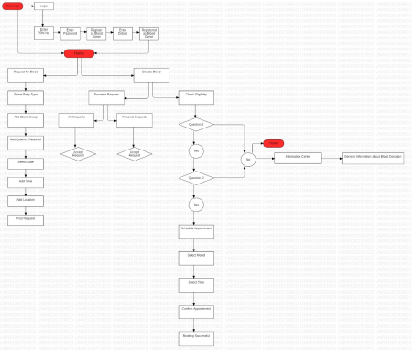

6

**USER CLASSES AND CHARACTERISTICS**

● Students can volunteer themselves for donating blood by booking their appointment with the blood banks near them.

● A user can see when he/she donated blood last and if the user is eligible for donating blood or not.

● It will be a small step towards creating a digital solution.

● It will help in spreading awareness about healthcare.

**SYSTEM REQUIREMENTS**

**Hardware Requirements:**

**For USER**

● An Android phone

● 2 GB Minimum RAM Required

● Mobile Data or Wi-Fi Connectivity

**For DEVELOPER**

● A personal computer

● 8 GB Minimum RAM Required

● Internet Connection

**Software Requirements:**

● Android Studio

Operating System (Windows/Linux/Mac OS)

**SUMMARY:**

We planned to establish an effective digital solution for blood donation for our project: HOPE. We've created a platform that allows us to identify blood donors and even donate blood through a blood donation camp listed on our app. This can be accomplished by taking the following steps:

1. The user must first register and then login to our app.
2. After logging in, the user will be required to take a simple self-assessment test.
3. After passing the exam, the user must meet an eligibility condition for blood donation, which is based on previous blood donation history and whether or not the user has any ailments.
4. If the user wants to donate blood, he or she can go to the events area and schedule an appointment for the nearest blood donation drive at a time that is convenient for them.
5. If a user needs blood and needs it now, he or she can go to the raise an issue tab and look for nearby blood donors who match the appropriate blood group.

11